**Name: Libiya Jose**

**Roll No: 14**

**Batch: MCA -B**

**Date:23-05-2022**

**NETWORKING & SYSTEM ADMINISTRATION LAB**

**Experiment No.: 23**

**Aim**

installing docker on ubuntu

**Procedure & Output**

**Steps for Installing Docker:**

1. Open the terminal on Ubuntu.

2. Remove any [Docker files](https://www.simplilearn.com/tutorials/docker-tutorial/what-is-dockerfile) that are running in the syst

em, using the following command:

                 $ sudo apt-get remove docker docker-engine docker.io

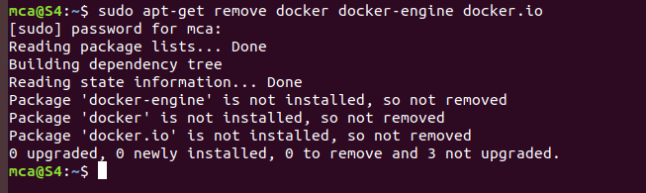

After entering the above command, you will need to enter the password of the root and press enter.

3. Check if the system is up-to-date using the following command

                     $ sudo apt-get update

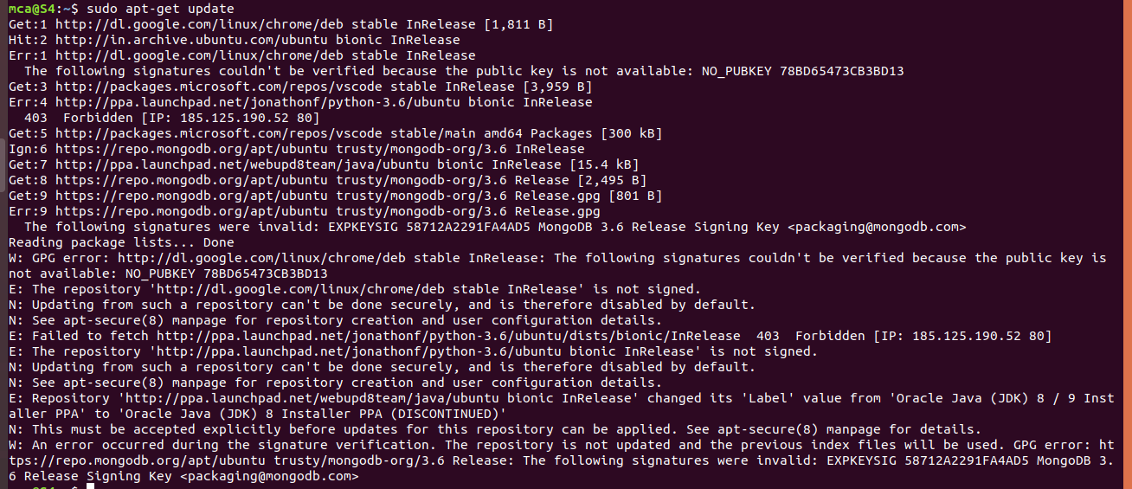

4. Install Docker using the following command

$ sudo apt install docker.io

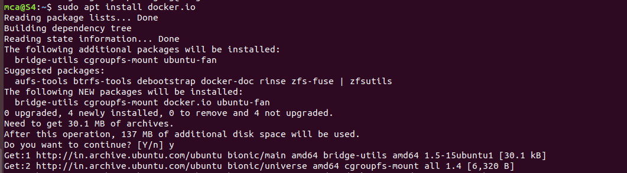

You’ll then get a prompt asking you to choose between y/n - choose *y*

5. Install all the dependency packages using the following command:

|  |
| --- |
| $ sudo snap install docker |

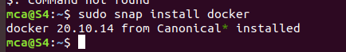

6. Before testing Docker, check the version installed using the following command:

$ docker --version

https://lh3.googleusercontent.com/MS26VusGiQItqJYcDXNQ23BDK7rMypEQmSG-g5j_e5o3RshWCahMRStXwEIIchTUmA12AEU8mI2eC7XrViq3T75bnsGqZDsJ3w0FldTRLrIicN5xViZt4KAH01PiBzsDN484ZdQ

7. Pull an image from the Docker hub using the following command:

$ sudo docker run hello-world

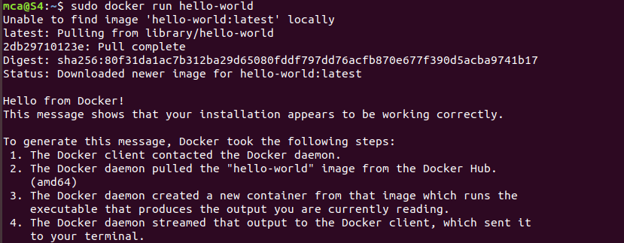

Here, *hello-world* is the docker image present on the Docker hub.

8. Check if the docker image has been pulled and is present in your system using the following command:

$ sudo docker images



9. To display all the containers pulled, use the following command:

$ sudo docker ps -a



10. To check for containers in a running state, use the following command:

$ sudo docker pss

You’ve just successfully installed Docker on Ubuntu!

https://lh6.googleusercontent.com/6ym5v7gZN-rbQzxxbLVhmRo7B8a_s9pt5yq4pn079zLQ92r92wer5wtZhMJqOuWNi6AnilkFInTp_mpr0zZKCbI-vlsxM-xeJsJ257Wo6zT_vLeg7qYM7s_e5K6EjAehDonnh58